**Design & Technology**

**

**Design communication**

**Materials required for questions**

* Pencil
* Rubber
* Calculator

**Instructions**

* Use black ink or ball-point pen
* Try answer all questions
* Use the space provided to answer questions
* Calculators can be used if necessary
* For the multiple choice questions, circle your answer

**Advice**

* Marks for each question are in brackets
* Read each question fully
* Try to answer every question
* Don’t spend too much time on one question

**Good luck!**

**Q1.** Which technique is most effective for presenting statistical data trends to clients?

**A** 3D sketching

**B** Graphs

**C** Report writing

**Q2.** What is the primary purpose of rendering in a design drawing?

**A** To add precise dimensions

**B** To enhance visual realism using colour/texture

**C** To create technical tables

**Q3.** Which method ensures components are manufactured to exact specifications?

**A** Mixed media collage

**B** 2D abstract sketching

**C** Dimensioning with tolerances

**Q4.** A designer uses isometric and orthographic views in a presentation. This demonstrates:

**A** Use of 2D/3D sketching

**B** Report writing standards

**C** Table formatting

**Q5.** Evaluate the following techniques for rendering a design:

* using computer aided design (CAD)
* hand generated **(6 marks)**

**Q6.** The images below show two different design communication techniques. Discuss why a designer may use each technique to communicate information **(6 marks)**

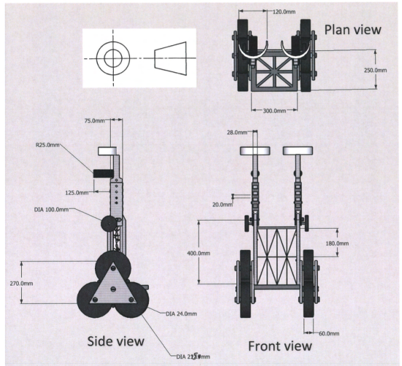

**Answers**

**Q1**. B

**Q2**. B

**Q3**. C

**Q4**. A

**Q5**.

CAD Rendering

* Costly software and powerful computer processors are needed which can make it prohibitive.
* A high degree of competency in the use of the CAD software is needed to fully exploit all functions which may require lengthy training.
* Software may require purchased credits to perform high quality renders adding to the cost of the technique.
* Photo realistic renders are feasible.
* A huge range of material textures are available.
* Light sources and shadow can be represented.
* Rendered images can be placed into scenarios.
* CAD can be emailed/shared for instant feedback from clients/focus groups.
* CAD renders can be easily edited.

Hand rendering

* A great deal of skill is needed to proficiently achieve a high quality render using markers, coloured pencils or inks etc.
* Specialist paper is needed to avoid the colours running.
* A hand rendered drawing can be time consuming to complete and takes longer than CAD.
* Tone and shadow can be achieved through a wide range of available colours.
* Flat smooth colours can be achieved with the use of a blender.
* Minimal specialist equipment is needed making the process more affordable than CAD.
* Hard to edit the render and usually would require restarting

**Q6.**

Exploded view:

* Designers may use exploded views to produce assembly instruction booklets for flat pack furniture to assist the consumer.
* Exploded views allow the viewer to see all components within a product clearly.
* Exploded views can be used on assembly lines to assist during production.
* Exploded views may be used to communication information on internal assemblies to a client during a design meeting.
* Using CAD software allows a designer to create an exploded view on screen and re-assemble a product virtually when working with a client so all components can be seen.
* Exploded views allow consumers to identify and order replacement parts.

Sectional view (Orthographic):

* Sectional views allow the viewer to see internal and hidden details within an assembly.
* Using 2D sectional views allows dimensions of hidden components to be added onto engineering drawings.
* Sectional views allow designers to visualise the interaction between separate hidden components.